**8 SCIENCE 2016**

### PHYSICS TEST ONE

Name: ____________________ Teacher: ___________________ Mark: /48

**Percentage: %**

**SECTION A: MULTIPLE CHOICE (15 marks)**

**Please circle your answer on the multiple choice answer grid below.**

1. A B C D 11. A B C D

2. A B C D 12. A B C D

3. A B C D 13. A B C D

4. A B C D 14. A B C D

5. A B C D 15. A B C D

6. A B C D

7. A B C D

8. A B C D

9. A B C D

10. A B C D

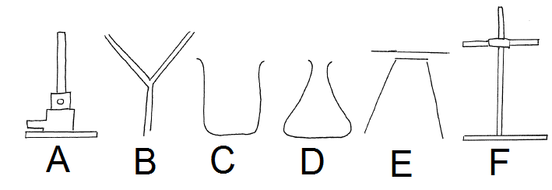Questions 1-5 are based on the diagram below.

**1.** Choose the laboratory equipment that is used to filter solutions so the solids stay in the paper

and the liquid passes through.

(a) A.

(b) B.

(c) D.

(d) E.

**2.** Select the name of laboratory equipment ‘D’.

(a) Beaker.

(b) Triangle flask.

(c) Conical flask.

(d) Cone flask.

**3.** Select the name of laboratory equipment ‘A’.

(a) Gas burner.

(b) Beaker burner.

(c) Bunsen burner.

(d) Flame burner.

**4.** Which two pieces of laboratory equipment is used to hold or heat chemicals?

(a) C and E.

(b) D and B.

(c) D and A.

(d) C and D.

**5.** Laboratory equipment ‘E’ is made up of:

(a) a stand and gauze mat.

(b) a retort stand and clamp.

(c) a tripod and gauze mat.

(d) a gauze mat and retort stand.

Questions 6-8 are based on the diagram below.

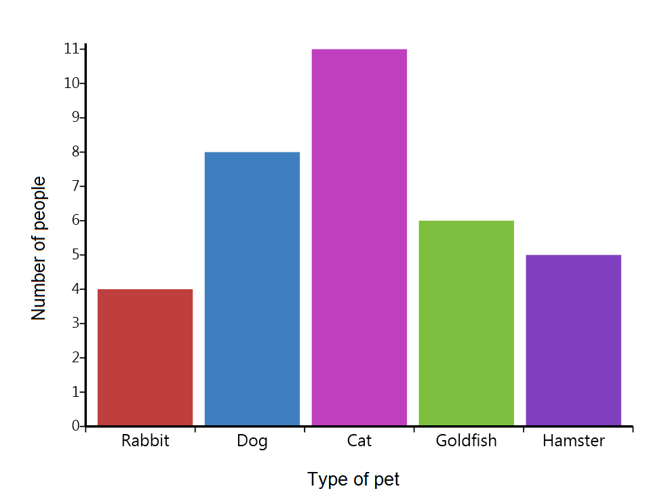

**6.** The independent variable for the graph above is:

(a) the type of pet.

(b) the type of people.

(c) number of people.

(d) number of animals.

**7.** The dependent variable for the graph above is:

(a) the type of pet.

(b) the type of people.

(c) number of people.

(d) number of animals.

**8.** The most **incorrect** title for the graph would be:

(a) the type of pet versus the number of people.

(b) the number of people that have different types of pets.

(c) the different types of pets.

(d) the number of people versus the type of pet.

**9.** How many people own a dog?

(a) 6.

(b) 7.

(c) 8.

(d) 9.

**10.** Any factors that can influence an experiment are called:

(a) variables.

(b) conditions.

(c) data.

(d) headings.

**11.** Select the correct ordering of the experimental write-up parts.

(a) Heading, aim, hypothesis, materials, method, results, discussion, conclusion.

(b) Heading, hypothesis, aim, materials, method, results, discussion, conclusion.

(c) Heading, aim, hypothesis, method, materials, results, discussion, conclusion.

(d) Heading, aim, hypothesis, materials, method, discussion, results, conclusion.

**12.** Select the data that is **NOT** qualitative.

(a) There are 3 ducks in the pond.

(b) There are five girls in the classroom.

(c) Molly’s hair is light brown.

(d) It will be 27°C on Friday.

**13.** Logical extension of a line graph is known as:

(a) an interpolation.

(b) the line of worst fit.

(c) the line of best fit.

(d) an extrapolation.

**14.** Using existing data points to find new data points is known as:

(a) an interpolation.

(b) the line of worst fit.

(c) the line of best fit.

(d) an extrapolation.

**15.** A straight line or curve drawn through the ‘centre’ of points on a graph is known as:

(a) an interpolation.

(b) the line of worst fit.

(c) the line of best fit.

(d) an extrapolation.

**SECTION B: SHORT ANSWER (33 marks)**

**1.** One of the eyes in the picture below is in the correct position to take an accurate measurement of

the position of the end of the spring.

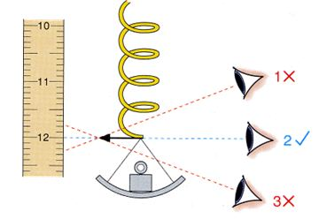

**a)** Circle the eye in the picture that is in the correct

position. (1 mark)

**b)** Identify the name of the error that can be caused by

looking at a measurement from an incorrect angle. (1 mark)

________________________________________________

**2. Explain** the difference between first-hand data and second-hand data.(2 marks)

____________________________________________________________________________________

____________________________________________________________________________________

____________________________________________________________________________________

____________________________________________________________________________________

____________________________________________________________________________________

**3.** Kim measured how many eggs his chicken laid over 7 days. His results are shown below.

|  |  |  |  |  |  |  |  |
| --- | --- | --- | --- | --- | --- | --- | --- |
|  | Day one | Day two | Day three | Day Four | Day Five | Day Six | Day Seven |
| Number of  eggs | 1 | 2 | 1 | 3 | 2 | 2 | 3 |

**a)** Calculate the average number of eggs that were laid each day. (Show working out) (2 marks)

**b)** Is this data that Kim collected qualitative or quantitative. Explain your answer. (2 marks)

____________________________________________________________________________________

____________________________________________________________________________________

____________________________________________________________________________________

____________________________________________________________________________________

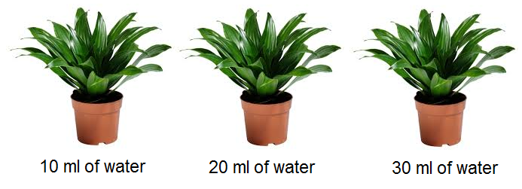**4.** Caitlin wanted to find out whether watering a plant

with different amounts of water would affect the rate

that it would grow. She gives one pot plant 10 ml of

water each day, a second pot plant 20 ml of water each

day and a third pot plant 30 ml of water each day. After

20 days she measures the height of each plant.

The results are shown in the table below.

|  |  |
| --- | --- |
| **Amount of water given (ml)** | **Height of pot plant (cm)** |
| **10** | 23 |
| **20** | 35 |
| **30** | 39 |

**a)** State the independent variable in this experiment. (1 mark)

____________________________________________________________________________________

**b)** State the dependent variable in this experiment. (1 mark)

____________________________________________________________________________________

**c)** List two variables that Caitlin would need to keep constant to keep the experiment fair

(controlled variables). (2 marks)

____________________________________________________________________________________

____________________________________________________________________________________

**d)** Write an aim for this experiment. (2 marks)

____________________________________________________________________________________

____________________________________________________________________________________

____________________________________________________________________________________

**e)** The data Caitlin collected was qualitative data. True or false (1 mark)

**f)** The data Caitlin collected was first-hand data. True or false (1 mark)

**g)** Caitlin spilt some water onto the floor when True or false (1 mark)

watering one of the plants. She made an error.

**h)** An error can be avoided. True or false (1 mark)

**5.**  Fill in the table below showing metric unit prefixes. (3 marks)

|  |  |  |
| --- | --- | --- |
| **Prefix name** | **Size** | **Prefix symbol** |
| milli | One-thousandth |  |
|  | One-hundredth | c |
| kilo | One thousand |  |

**6a.** Use the graph below to work out the distance that would be covered in 4 hours. (1 mark)

____________________________________________________________________________________

**b.** State the name given to this process of estimating a data point. (1 mark)

____________________________________________________________________________________

**c.** Use the graph below to work out the time it would take to cover 15 km. (1 mark)

____________________________________________________________________________________

**d.** State the name given to this process of estimating a data point. (1 mark)

____________________________________________________________________________________

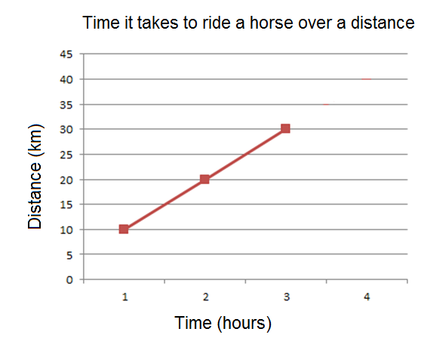

**7.**  Fill in the table below showing units of measurements and their symbols. (8 marks)

|  |  |
| --- | --- |
| **Unit of measurement** | **Symbol** |
| Minutes |  |
| Milligrams |  |
| Kilograms |  |
|  | m |
| Grams |  |
|  | h |
| Litres |  |
| Joules |  |

**Only do this page when you have attempted**

**EVERY SINGLE QUESTION in the test!**

